# LINUX NETWORK PACKET STATISTICS DISPLAY PROJECT USER & TESTING MANNUAL DOCUMENT

Table of Contents

1.**USER MANUAL** 3

1. INSTALLATION 3

2. USAGE 3

a) *Starting the Program:* 3

*b)* *Interactive Shell:* 3

c) *Viewing Captured Data:* 3

3. TROUBLESHOOTING 4

2.**TESTING** 4

# 1.**USER MANUAL**

# INSTALLATION

1. *Requirements:*

* Operating System: Linux-based distribution (recommended)
* C compiler (e.g., GCC)

1. *Steps*:

* Clone or download the source code from the repository.
* Open a terminal and navigate to the directory containing the source code.
* Compile the program using the provided Makefile or by running

**gcc packet_sniffer.c -o packet_sniffer**

* Ensure that the necessary libraries and dependencies are installed (e.g., **libpcap-dev** for packet capturing).

# USAGE

# *Starting the Program:*

* + 1. Run the compiled executable **packet_sniffer** in the terminal.
    2. If desired, provide command-line arguments to specify which protocols to capture (1 for TCP, 2 for UDP).
    3. Alternatively, start the program without command-line arguments to enter the interactive shell.

# *Interactive Shell:*

* + 1. Upon starting the program without command-line arguments, an interactive shell prompt will appear.
    2. Follow the on-screen instructions to select protocols and choose how to print captured data.
    3. Use the provided menu options to navigate and make selections.
  1. *Viewing Captured Data:*
     1. The program logs captured TCP packets to **tcp.txt** and UDP packets to **udp.txt**.
     2. After capturing packets, use a text editor or command-line tools to view the contents of these log files.
     3. Alternatively, select the print format option in the interactive shell to display captured data directly in the terminal.

# TROUBLESHOOTING

* If the program encounters errors or crashes, refer to any error messages displayed in the terminal for guidance.
* Check that the required permissions are set for capturing network packets (e.g., running the program with root privileges).
* Ensure that the correct network interface is selected for packet capture, especially in environments with multiple network interfaces.

# 2.**TESTING**

**1.Compilation and running the program using sudo ./packet**

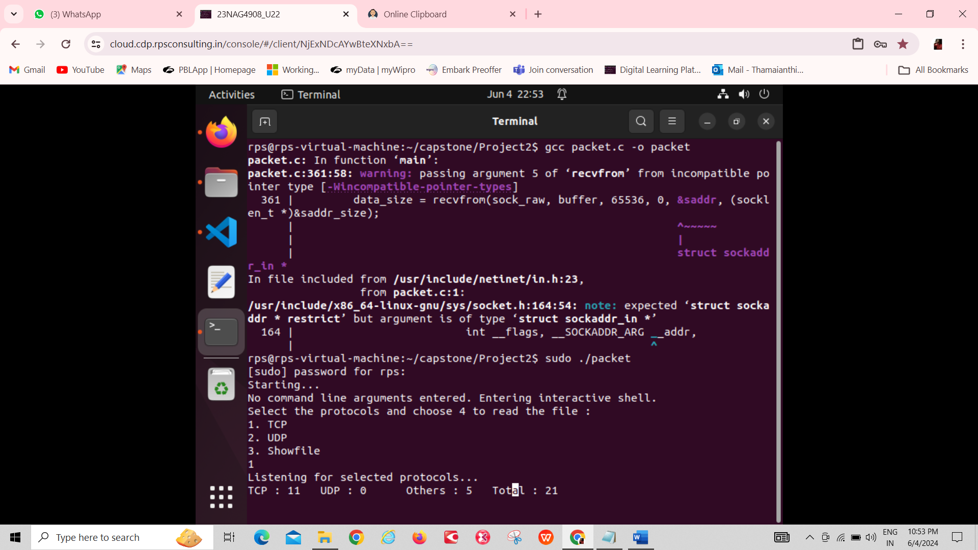

**2.Reading the file and displaying in the graph format**

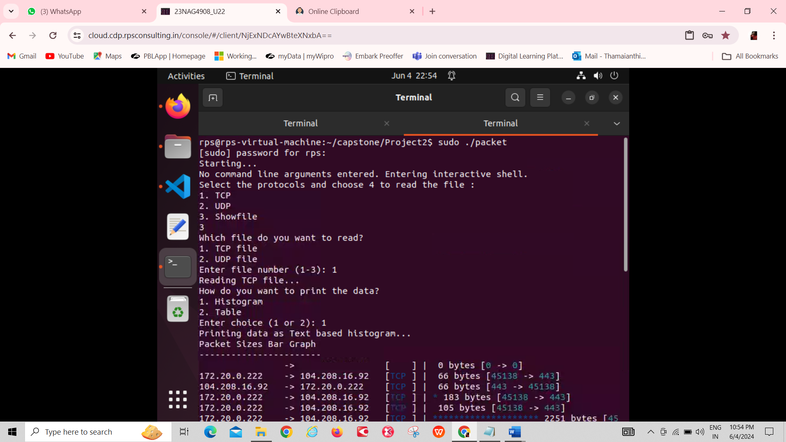

**3.Reading the files and displaying in the form of table.**

